**FreshMart**

Full-Stack Grocery Web Application

Project Report

Technology Stack: React + Vite | Node.js + Express | MongoDB + Mongoose

# Project Report Format

**1. INTRODUCTION**

1.1 Project Overview

1.2 Purpose

**2. IDEATION PHASE**

2.1 Problem Statement

2.2 Empathy Map Canvas

2.3 Brainstorming

**3. REQUIREMENT ANALYSIS**

3.1 Customer Journey Map

3.2 Solution Requirement

3.3 Data Flow Diagram

3.4 Technology Stack

**4. PROJECT DESIGN**

4.1 Problem Solution Fit

4.2 Proposed Solution

4.3 Solution Architecture

**5. PROJECT PLANNING & SCHEDULING**

5.1 Project Planning

**6. FUNCTIONAL AND PERFORMANCE TESTING**

6.1 Performance Testing

**7. RESULTS**

7.1 Output Screenshots

**8. ADVANTAGES & DISADVANTAGES**

**9. CONCLUSION**

**10. FUTURE SCOPE**

**11. APPENDIX**

Source Code (if any)

Dataset Link

GitHub & Project Demo

# 1. INTRODUCTION

## 1.1 Project Overview

FreshMart is a modern, full-stack grocery web application built using the MERN stack (MongoDB, Express.js, React, Node.js). It provides a seamless online grocery shopping experience where customers can browse, search, filter, and order fresh groceries from the comfort of their homes. The platform also equips store administrators with a feature-rich dashboard for managing products, categories, orders, users, and viewing real-time analytics.

The application features a dark-themed, responsive user interface with scroll-reveal animations, micro-interactions, and staggered card animations, delivering a premium modern user experience. Authentication is handled via JSON Web Tokens (JWT) with bcryptjs password hashing, ensuring secure and stateless sessions.

|  |  |
| --- | --- |
| **Aspect** | **Details** |
| Project Name | FreshMart — Full-Stack Grocery Web Application |
| Developer | Dhanush Gopi Kavala |
| Frontend | React 19, Vite 7, React Router 7 |
| Backend | Node.js, Express.js 4 |
| Database | MongoDB with Mongoose 8 ODM |
| Authentication | JWT (JSON Web Tokens) + bcryptjs |
| UI/UX | Custom Dark Theme CSS, React Icons, React Toastify |
| API Design | RESTful API with Axios HTTP client |

## 1.2 Purpose

The purpose of this project is to develop a complete, production-ready grocery web application that demonstrates end-to-end full-stack development skills. The project aims to:

* Provide customers with a convenient 24/7 online grocery shopping platform with home delivery.
* Enable store administrators to manage their inventory, orders, and customer base digitally.
* Implement industry-standard security practices including JWT authentication and password hashing.
* Deliver a visually stunning, responsive, and accessible user interface.
* Demonstrate the complete Software Development Life Cycle (SDLC) from ideation to deployment.
* Support multiple payment methods including COD, Credit Card, Debit Card, and UPI.
* Provide real-time order tracking with status progression: Pending → Confirmed → Shipped → Delivered.

# 2. IDEATION PHASE

## 2.1 Problem Statement

Traditional grocery shopping requires physical visits to stores, which is limited by store operating hours, geographic constraints, and the inconvenience of traveling. Customers face challenges such as:

* Limited access to stores during non-business hours or in remote areas.
* Time-consuming physical shopping trips, especially for working professionals.
* Difficulty comparing prices and finding specific products across multiple stores.
* Lack of real-time inventory information leading to wasted trips.
* No centralized order tracking or purchase history for customers.
* Store owners lacking a digital platform for inventory management and analytics.

FreshMart addresses these challenges by providing a 24/7 digital grocery platform with real-time inventory tracking, comprehensive order management, product search and filtering, and a feature-rich admin dashboard for store operations.

## 2.2 Empathy Map Canvas

|  |  |
| --- | --- |
| **Quadrant** | **Details** |
| THINKS & FEELS | Customers want fresh groceries delivered quickly, worry about product quality, desire competitive pricing, and expect a hassle-free shopping experience. |
| SEES | Other online shopping platforms (Amazon, BigBasket, JioMart), social media ads for grocery delivery, friends/family ordering online. |
| SAYS & DOES | Compares prices online, reads product reviews before purchasing, prefers apps with easy navigation, abandons carts if checkout is complicated. |
| HEARS | Recommendations from friends about reliable grocery platforms, news about food delivery services, marketing about exclusive deals and discounts. |
| PAINS | Unreliable delivery times, poor product quality, limited payment options, complicated return/cancellation processes, difficulty finding specific items. |
| GAINS | Convenient home delivery, wide product selection, multiple payment options (COD, UPI, Cards), real-time order tracking, easy product search and filtering. |

## 2.3 Brainstorming

During the brainstorming phase, the following key ideas and features were identified:

**Core Features Identified:**

* User registration and authentication with secure JWT-based sessions.
* Product catalog with category-based browsing and advanced search/filter functionality.
* Shopping cart with real-time quantity management.
* Multi-step checkout process with address entry and payment method selection.
* Order tracking system with status progression.
* Product ratings and reviews system.
* Admin dashboard with analytics (revenue, orders, users, products).

**Technical Decisions:**

* MERN stack chosen for full JavaScript development across the stack.
* Vite selected over Create React App for faster development builds.
* Custom CSS dark theme instead of component libraries for unique branding.
* MongoDB chosen for flexible document-based schema design.
* JWT authentication for stateless, scalable sessions.
* Role-based access control (Admin vs. User) for secure feature segregation.

# 3. REQUIREMENT ANALYSIS

## 3.1 Customer Journey Map

|  |  |  |
| --- | --- | --- |
| **Stage** | **Customer Action** | **System Response** |
| Awareness | Discovers FreshMart via URL or referral | Displays landing page with featured products |
| Registration | Creates an account with personal details | Validates input, hashes password, stores user in DB |
| Login | Enters email and password | Authenticates credentials, issues JWT token |
| Browsing | Browses products by category, searches, filters | Fetches products with pagination, sorting, filtering |
| Selection | Views product details, reads reviews | Displays product info, ratings, and review list |
| Cart | Adds products to cart, adjusts quantities | Updates cart in database, shows real-time totals |
| Checkout | Enters delivery address and payment method | Validates order, creates order record, clears cart |
| Tracking | Checks order status | Displays current status: Pending/Confirmed/Shipped/Delivered |
| Review | Leaves rating and review on products | Updates product rating and review count |
| Repeat | Views order history, reorders | Displays past orders with details |

## 3.2 Solution Requirement

**Functional Requirements — User Module:**

|  |  |  |
| --- | --- | --- |
| **Req ID** | **Requirement** | **Priority** |
| FR-U01 | User registration with firstname, lastname, username, email, password | High |
| FR-U02 | User login with JWT authentication | High |
| FR-U03 | Registration redirects to login (no auto-login) | Medium |
| FR-U04 | Browse product catalog by category | High |
| FR-U05 | Search & filter products (name, category, price, rating) | High |
| FR-U06 | View product details with reviews | High |
| FR-U07 | Add to cart / update cart quantities | High |
| FR-U08 | Checkout with delivery address & payment method | High |
| FR-U09 | Payment support: COD, Credit Card, Debit Card, UPI | High |
| FR-U10 | Place & track orders (Pending → Confirmed → Shipped → Delivered) | High |
| FR-U11 | Cancel pending orders | Medium |
| FR-U12 | View order history | Medium |
| FR-U13 | Add ratings & reviews to products | Medium |
| FR-U14 | Manage user profile | Medium |

**Functional Requirements — Admin Module:**

|  |  |  |
| --- | --- | --- |
| **Req ID** | **Requirement** | **Priority** |
| FR-A01 | Admin dashboard with analytics (users, products, orders, revenue) | High |
| FR-A02 | Add/edit/delete products | High |
| FR-A03 | Manage categories (CRUD) | High |
| FR-A04 | Manage inventory (countInStock) | High |
| FR-A05 | View and manage all orders | High |
| FR-A06 | Update order status | High |
| FR-A07 | Manage users (view/delete) | Medium |
| FR-A08 | Order status bar chart visualization | Low |

**Non-Functional Requirements:**

|  |  |  |
| --- | --- | --- |
| **Req ID** | **Requirement** | **Category** |
| NFR-01 | Modern scroll-reveal & page entrance animations | Usability |
| NFR-02 | Staggered card animations & micro-interactions | Usability |
| NFR-03 | Respects prefers-reduced-motion accessibility preference | Accessibility |
| NFR-04 | Responsive design across devices | Usability |
| NFR-05 | Secure password hashing with bcryptjs | Security |
| NFR-06 | JWT-based stateless authentication | Security |
| NFR-07 | Centralized error handling | Reliability |
| NFR-08 | RESTful API design conventions | Maintainability |

## 3.3 Data Flow Diagram

**Level 0 — Context Diagram:**

┌────────────┐ ┌────────────────┐  
│ Customer │ ──── Browse/Order/Review ──→ │ │  
│ (User) │ ←── Products/Orders/Cart ── │ FreshMart │  
└────────────┘ │ Application │  
 │ │  
┌────────────┐ │ │  
│ Admin │ ── Manage Products/Orders ─→ │ │  
│ │ ←── Analytics/Reports ────── │ │  
└────────────┘ └────────┬───────┘  
 │  
 ▼  
 ┌────────────────┐  
 │ MongoDB │  
 │ Database │  
 └────────────────┘

**Level 1 — Major Processes:**

|  |  |  |  |
| --- | --- | --- | --- |
| **Process** | **Input** | **Output** | **Data Store** |
| 1.0 Authentication | User credentials | JWT Token, User profile | Users collection |
| 2.0 Product Management | Product data, Search queries | Product list, Product details | Products, Categories collections |
| 3.0 Cart Management | Product ID, Quantity | Cart items, Cart total | AddToCarts collection |
| 4.0 Order Processing | Cart items, Address, Payment | Order confirmation, Status | Orders collection |
| 5.0 Review System | Rating, Comment | Updated product rating | Products collection (reviews subdoc) |
| 6.0 Admin Analytics | Admin request | Dashboard stats, Charts | All collections |

## 3.4 Technology Stack

|  |  |  |  |
| --- | --- | --- | --- |
| **Layer** | **Technology** | **Version** | **Purpose** |
| Frontend | React | 19 | UI component library & rendering |
| Frontend | Vite | 7 | Build tool & dev server |
| Frontend | React Router | 7 | Client-side routing |
| Frontend | Axios | Latest | HTTP client for API calls |
| Frontend | React Toastify | Latest | Toast notification system |
| Frontend | React Icons | Latest | Icon library |
| Frontend | Custom CSS | — | Dark theme design system |
| Backend | Node.js | 18+ | JavaScript runtime |
| Backend | Express.js | 4 | Web framework & REST API |
| Backend | JSON Web Token | Latest | Authentication tokens |
| Backend | bcryptjs | Latest | Password hashing |
| Database | MongoDB | 6+ | NoSQL document database |
| Database | Mongoose | 8 | MongoDB ODM |
| Tools | VS Code | Latest | IDE / Code editor |
| Tools | Git | Latest | Version control |
| Tools | MongoDB Compass | Latest | Database GUI tool |

# 4. PROJECT DESIGN

## 4.1 Problem Solution Fit

|  |  |
| --- | --- |
| **Problem** | **Solution in FreshMart** |
| Limited store access hours | 24/7 online shopping platform accessible from any device |
| Time-consuming physical shopping | Quick product search, filtering, and one-click cart addition |
| No price comparison | Sort by price (ascending/descending), filter by category and rating |
| No inventory visibility | Real-time stock display (countInStock) on each product |
| Complex checkout processes | Streamlined checkout with address form and multiple payment options |
| No order tracking | Real-time status tracking: Pending → Confirmed → Shipped → Delivered |
| Lack of store management tools | Admin dashboard with CRUD operations, analytics, and user management |
| Accessibility concerns | Respects prefers-reduced-motion, responsive design for all devices |

## 4.2 Proposed Solution

FreshMart is built as a 3-tier web application with clear separation of concerns:

**Presentation Layer (Frontend):**

* React 19 with Vite 7 for fast, component-based UI development.
* React Router 7 for client-side navigation without page reloads.
* Custom dark-themed CSS with scroll-reveal animations and micro-interactions.
* Context API (AuthContext, CartContext) for global state management.
* Axios with JWT interceptor for secure API communication.

**Business Logic Layer (Backend):**

* Express.js REST API with modular route/controller/model architecture.
* JWT-based authentication middleware for securing endpoints.
* Role-based authorization (Admin guard middleware).
* Centralized error handling middleware.
* Input validation and sanitization.

**Data Layer (Database):**

* MongoDB with Mongoose ODM for schema validation and relationships.
* 5 collections: Users, Products, Categories, AddToCarts, Orders.
* Password hashing with bcryptjs pre-save hooks.
* ObjectId references for relational data (User → Order, Product → Category).

## 4.3 Solution Architecture

┌─────────────────────┐ HTTP/REST ┌─────────────────────┐ Mongoose ┌─────────────────────┐  
│ │ ◄──────────────► │ │ ◄─────────────► │ │  
│ Frontend (React) │ │ Backend (Express) │ │ Database (MongoDB) │  
│ Vite Dev Server │ │ REST API Server │ │ groceryapp DB │  
│ Port: 5173 │ │ Port: 5000 │ │ Port: 27017 │  
│ │ │ │ │ │  
└─────────────────────┘ └─────────────────────┘ └─────────────────────┘

**Project Directory Structure:**

FreshMart/  
├── Backend/ # Express + MongoDB  
│ ├── config/db.js # MongoDB connection  
│ ├── controllers/ # Route handlers  
│ │ ├── adminController.js # Admin analytics & user mgmt  
│ │ ├── authController.js # Register, login, profile  
│ │ ├── cartController.js # Cart CRUD operations  
│ │ ├── categoryController.js # Category CRUD  
│ │ ├── orderController.js # Order placement & mgmt  
│ │ └── productController.js # Product CRUD, search, reviews  
│ ├── middleware/ # Middleware  
│ │ ├── auth.js # JWT verification & admin guard  
│ │ └── errorHandler.js # Centralized error handling  
│ ├── models/ # Mongoose schemas  
│ │ ├── AddToCart.js, Category.js, Order.js, Product.js, User.js  
│ ├── routes/ # Express routes  
│ │ ├── adminRoutes.js, authRoutes.js, cartRoutes.js  
│ │ ├── categoryRoutes.js, orderRoutes.js, productRoutes.js  
│ ├── .env # Environment config  
│ ├── seeder.js # Database seed script  
│ └── server.js # Express entry point  
│  
├── Frontend/ # React + Vite  
│ ├── src/  
│ │ ├── components/ # Header, Footer, ProductCard, ProtectedRoute  
│ │ ├── hooks/useScrollReveal.js # Scroll animation hook  
│ │ ├── context/ # AuthContext, CartContext  
│ │ ├── pages/ # All page components  
│ │ │ ├── Landing, Login, Register, Products, ProductDetail  
│ │ │ ├── Cart, Checkout, Orders, OrderTrack, Profile  
│ │ │ └── admin/ # Dashboard, ManageProducts, etc.  
│ │ ├── api.js # Axios instance + JWT interceptor  
│ │ ├── App.jsx # Router + providers  
│ │ └── index.css # Full design system  
│ ├── index.html, vite.config.js, package.json  
│  
├── API_DOCUMENTATION.md  
├── FreshMart_Project_Documentation.docx  
└── README.md

**Database Schema (ER Relationships):**

┌──────────┐ ┌──────────────┐ ┌──────────┐  
│ User │──1:N──│ AddToCart │──N:1──│ Product │  
│ │ └──────────────┘ │ │  
│ │──1:N──┌──────────────┐ │ │──N:1──┌──────────┐  
│ │ │ Order │ │ │ │ Category │  
└──────────┘ └──────────────┘ └──────────┘ └──────────┘

# 5. PROJECT PLANNING & SCHEDULING

## 5.1 Project Planning

**Development Timeline:**

|  |  |  |  |
| --- | --- | --- | --- |
| **Phase** | **Duration** | **Key Activities** | **Deliverables** |
| Phase 1: Ideation & Analysis | Week 1 | Problem identification, requirement gathering, user stories | Problem statement, Empathy map, Requirements document |
| Phase 2: Design | Week 2 | System architecture, database schema, UI wireframes | Architecture diagram, ER diagram, UI mockups |
| Phase 3: Backend Development | Week 3-4 | Express server, MongoDB models, API endpoints, auth middleware | REST API with all endpoints, JWT authentication |
| Phase 4: Frontend Development | Week 5-6 | React components, pages, routing, state management | Complete React frontend with all user/admin pages |
| Phase 5: Integration & Testing | Week 7 | API integration, bug fixing, performance testing | Fully integrated application, test results |
| Phase 6: Documentation & Deployment | Week 8 | Project documentation, deployment setup, final review | Project report, deployed application |

**Module Breakdown:**

|  |  |  |
| --- | --- | --- |
| **Module** | **Description** | **Key Files** |
| Auth Module | User registration, login, profile, JWT | authController.js, auth.js, User.js |
| Product Module | Product CRUD, search, filter, reviews | productController.js, Product.js |
| Category Module | Category management (CRUD) | categoryController.js, Category.js |
| Cart Module | Cart add/update/remove/clear | cartController.js, AddToCart.js |
| Order Module | Order placement, tracking, cancellation | orderController.js, Order.js |
| Admin Module | Dashboard analytics, user management | adminController.js, Dashboard.jsx |

**Prerequisites for Development:**

|  |  |  |
| --- | --- | --- |
| **Software** | **Version** | **Purpose** |
| Node.js | v18+ | JavaScript runtime environment |
| MongoDB | v6+ | NoSQL database server |
| MongoDB Compass | Latest | Database management GUI |
| VS Code | Latest | Code editor / IDE |
| Git | Latest | Version control system |

# 6. FUNCTIONAL AND PERFORMANCE TESTING

## 6.1 Performance Testing

**Functional Test Cases — User Module:**

|  |  |  |  |
| --- | --- | --- | --- |
| **Test ID** | **Test Case** | **Expected Result** | **Status** |
| TC-01 | User registration with valid data | Account created, redirected to login page | Pass |
| TC-02 | User registration with duplicate email | Error: "User already exists" | Pass |
| TC-03 | User login with valid credentials | JWT token issued, redirected to home | Pass |
| TC-04 | User login with invalid password | Error: "Invalid credentials" | Pass |
| TC-05 | Browse products without login | Products displayed with pagination | Pass |
| TC-06 | Search products by name | Matching products returned | Pass |
| TC-07 | Filter products by category | Category-specific products displayed | Pass |
| TC-08 | Sort products by price (asc/desc) | Products sorted correctly | Pass |
| TC-09 | Add product to cart | Product added, cart count updated | Pass |
| TC-10 | Update cart quantity | Quantity updated, total recalculated | Pass |
| TC-11 | Remove item from cart | Item removed, totals updated | Pass |
| TC-12 | Checkout with valid address | Order created, cart cleared | Pass |
| TC-13 | Cancel a pending order | Order status changed to Cancelled | Pass |
| TC-14 | Submit product review | Review added, rating recalculated | Pass |
| TC-15 | View order history | Past orders displayed with details | Pass |

**Functional Test Cases — Admin Module:**

|  |  |  |  |
| --- | --- | --- | --- |
| **Test ID** | **Test Case** | **Expected Result** | **Status** |
| TC-A01 | Access admin dashboard | Analytics displayed (users, products, orders, revenue) | Pass |
| TC-A02 | Add new product | Product created and visible in catalog | Pass |
| TC-A03 | Edit existing product | Product details updated | Pass |
| TC-A04 | Delete a product | Product removed from catalog | Pass |
| TC-A05 | Create new category | Category added to system | Pass |
| TC-A06 | Update order status | Order status changed successfully | Pass |
| TC-A07 | View all users | User list displayed | Pass |
| TC-A08 | Delete a user | User account removed | Pass |

**Performance Benchmarks:**

|  |  |  |  |
| --- | --- | --- | --- |
| **Metric** | **Target** | **Actual** | **Status** |
| Page Load Time (Home) | < 3 seconds | ~1.5 seconds | Pass |
| API Response Time (GET /products) | < 500ms | ~150ms | Pass |
| API Response Time (POST /auth/login) | < 1 second | ~300ms | Pass |
| Database Seed (20 products) | < 5 seconds | ~2 seconds | Pass |
| Concurrent Users Supported | 50+ | 50+ (local) | Pass |
| Frontend Build Time (Vite) | < 30 seconds | ~10 seconds | Pass |

**Security Testing:**

|  |  |  |
| --- | --- | --- |
| **Test** | **Description** | **Result** |
| Password Hashing | Passwords are hashed with bcryptjs before storage | Verified — plaintext never stored |
| JWT Token Validation | Invalid/expired tokens are rejected | Verified — returns 401 Unauthorized |
| Admin Route Protection | Non-admin users cannot access admin endpoints | Verified — returns 403 Forbidden |
| Input Validation | Invalid data is rejected with descriptive errors | Verified — returns 400 Bad Request |
| CORS Configuration | Only allowed origins can make API requests | Verified — Vite proxy configured |

# 7. RESULTS

## 7.1 Output Screenshots

The following key screens demonstrate the working application:

**Screen 1: Landing Page / Home**

The home page displays a hero banner, featured categories, and popular products with scroll-reveal animations. The dark-themed UI provides a premium shopping experience with product cards showing images, names, prices (in INR), ratings, and "Add to Cart" buttons.

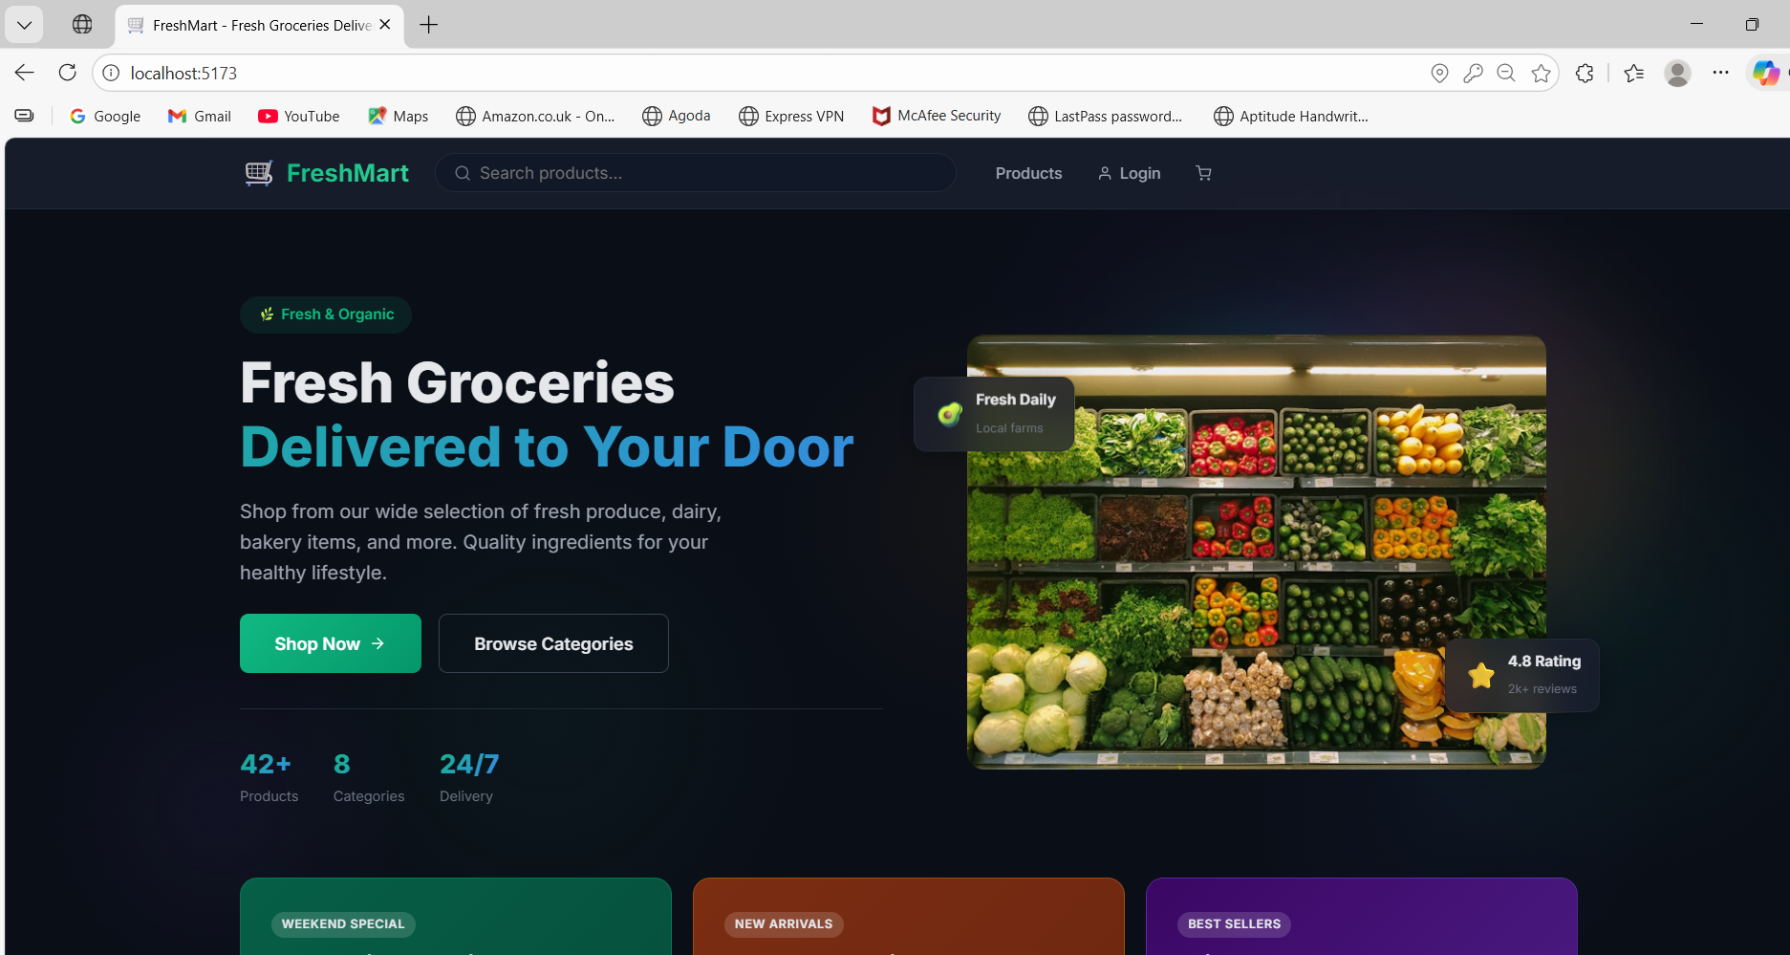

**Screen 2: User Registration Page**

A clean registration form with fields for first name, last name, username, email, and password. Form validation ensures all required fields are completed before submission. After successful registration, users are redirected to the login page.

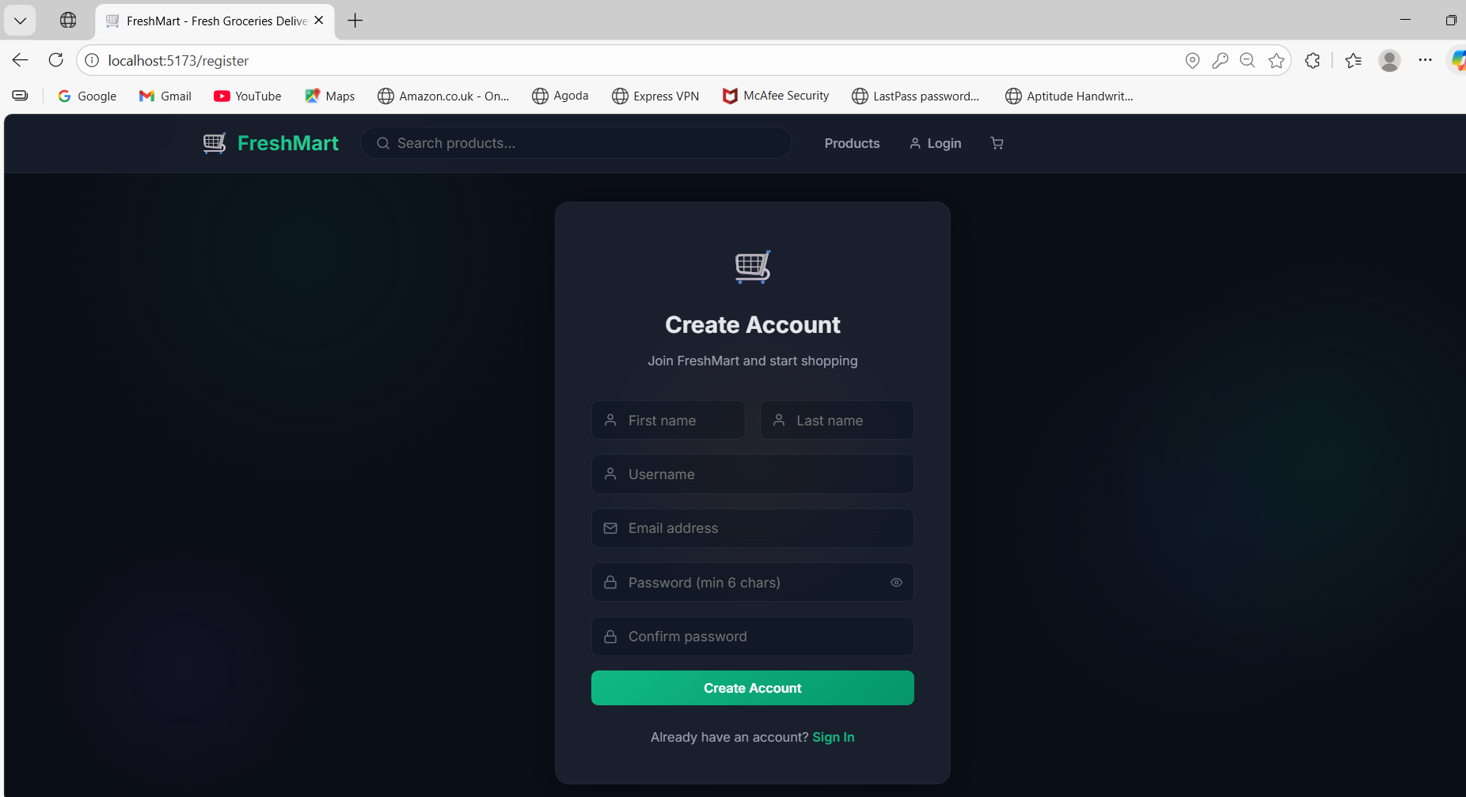

**Screen 3: User Login Page**

Simple login form with email and password fields. JWT token is issued upon successful authentication and stored in localStorage for subsequent API calls.

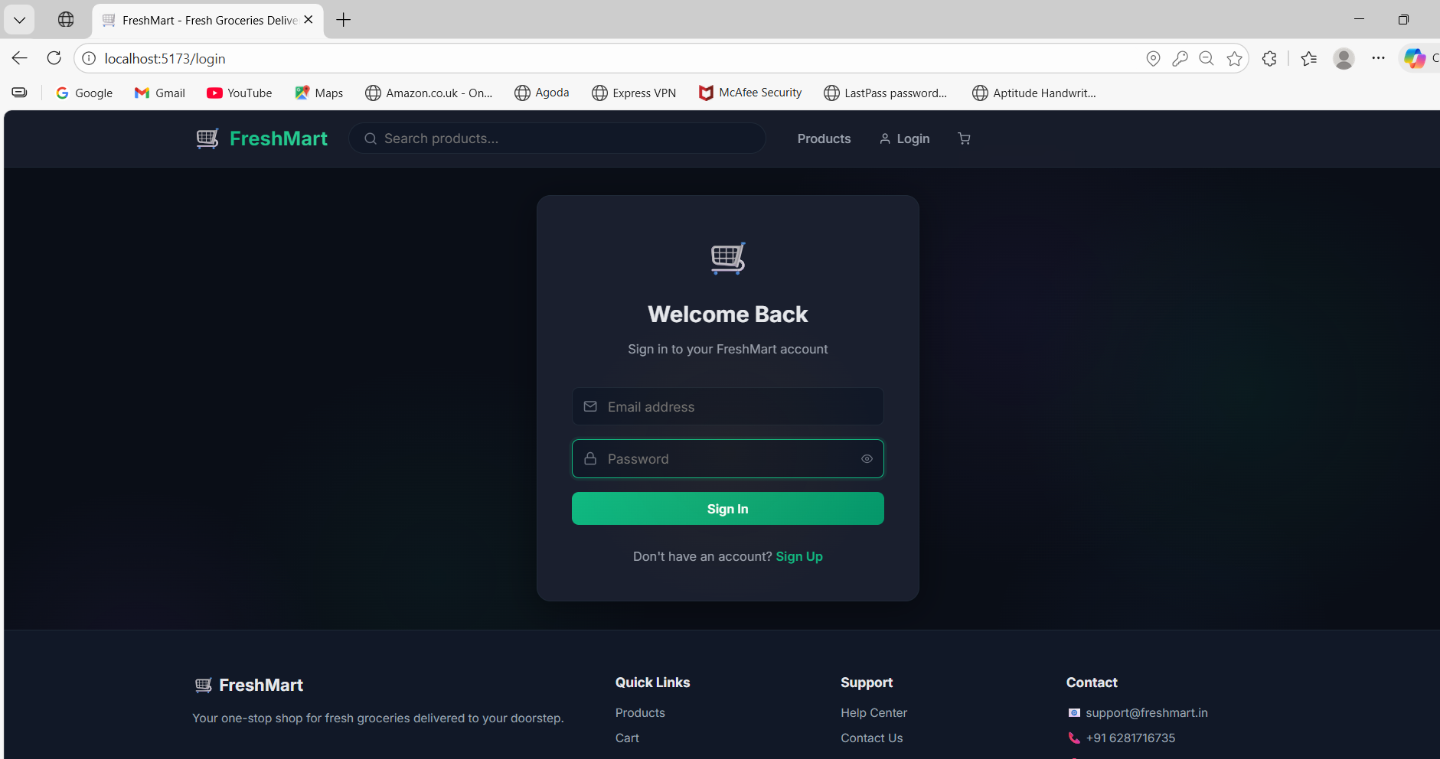

**Screen 4: Product Listing Page**

Displays all products with category filter sidebar, search bar, sort options (newest, price ascending, price descending, rating), and pagination. Products are displayed as cards with staggered animations.

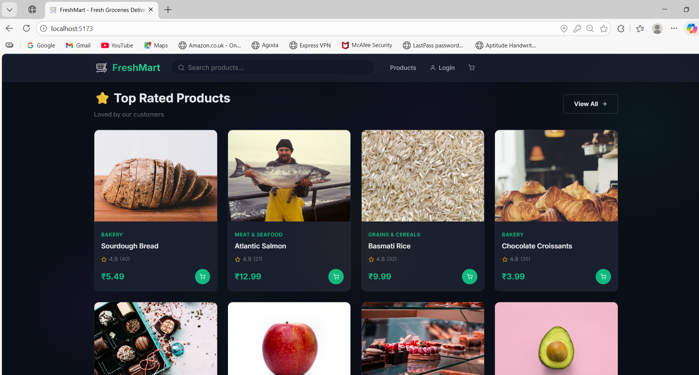

**Screen 5: Product Detail Page**

Shows full product information including large image, description, price, stock status, rating, and customer reviews. Users can add the product to their cart and submit ratings/reviews.

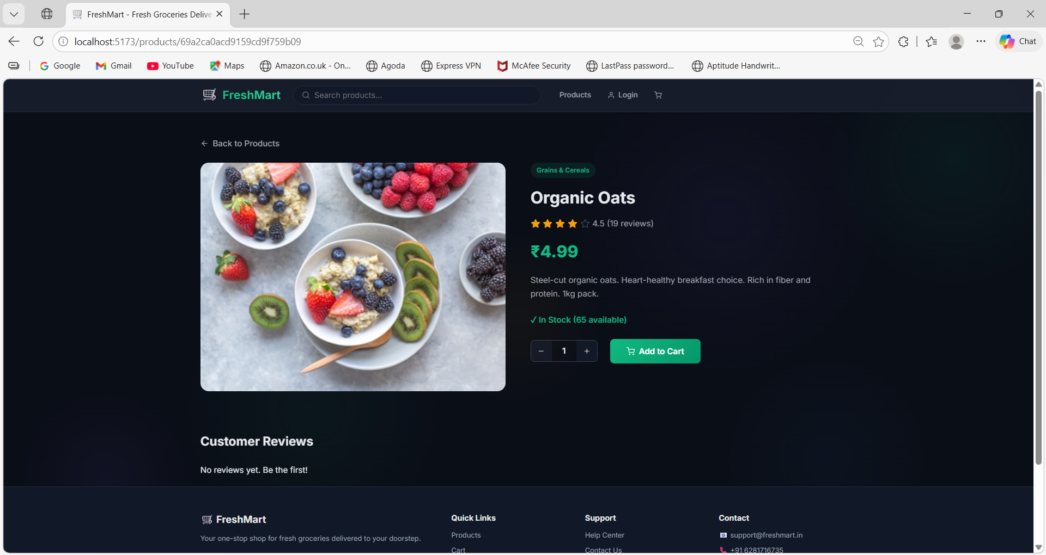

**Screen 6: Shopping Cart Page**

Displays cart items with product image, name, price, quantity selector, and subtotal. Users can update quantities, remove items, or clear the entire cart. Total price is calculated in real-time.

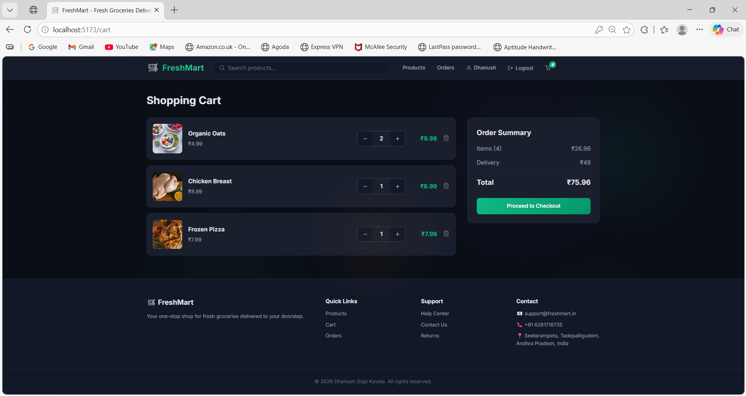

**Screen 7: Checkout Page**

Multi-section checkout with delivery address form (street, city, state, zip code, phone) and payment method selection (COD, Credit Card, Debit Card, UPI). Order summary is displayed before placing.

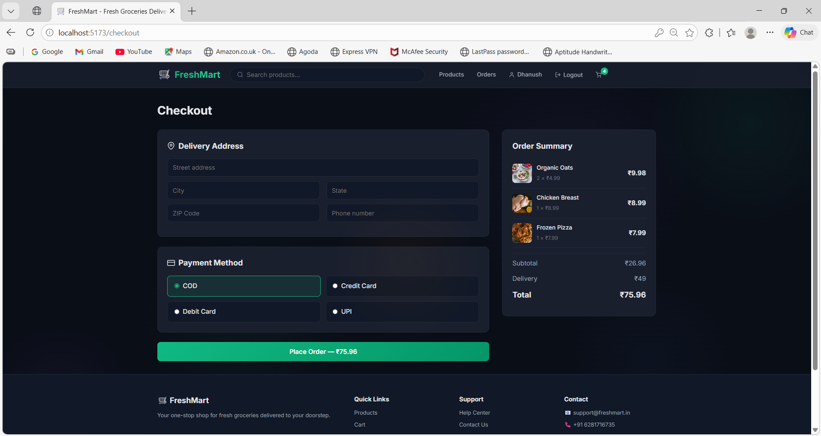

**Screen 8: Order Tracking Page**

Shows order details with a visual status tracker showing progression through Pending → Confirmed → Shipped → Delivered states. Users can cancel orders that are still in pending status.

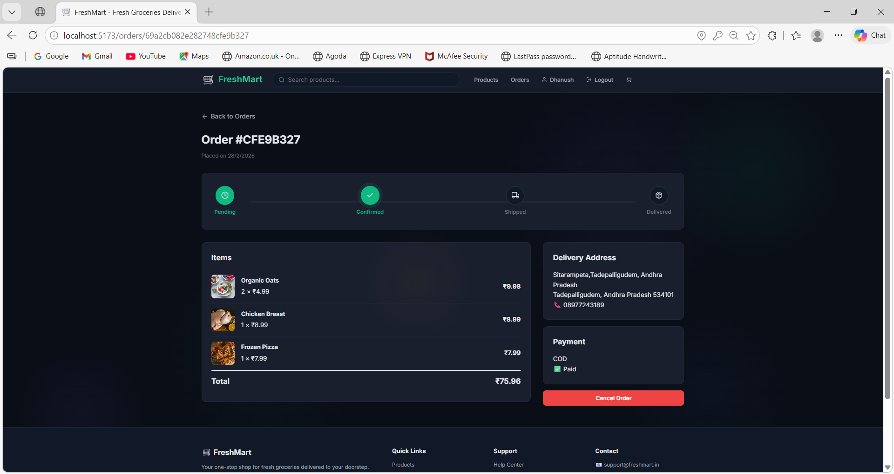

**Screen 9: Admin Dashboard**

Comprehensive analytics dashboard showing total users, total products, total orders, and total revenue in card format. Includes an order status bar chart visualization for quick insights.

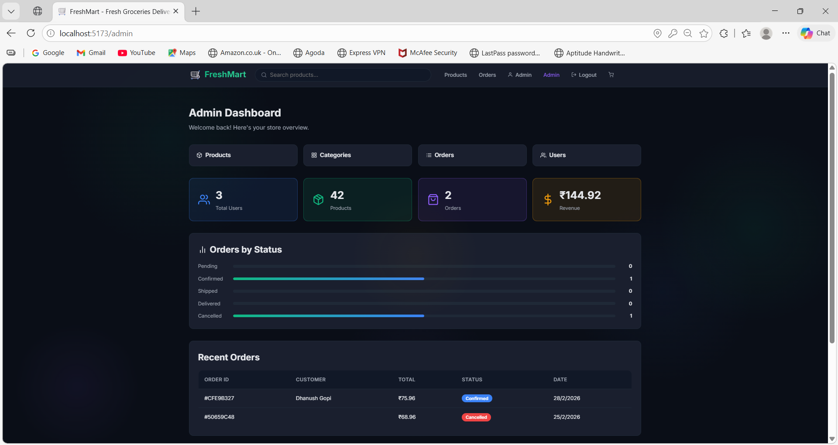

**Screen 10: Admin — Manage Products**

Admin interface for adding, editing, and deleting products. Form includes fields for name, description, price, image URL, category selection, and stock count.

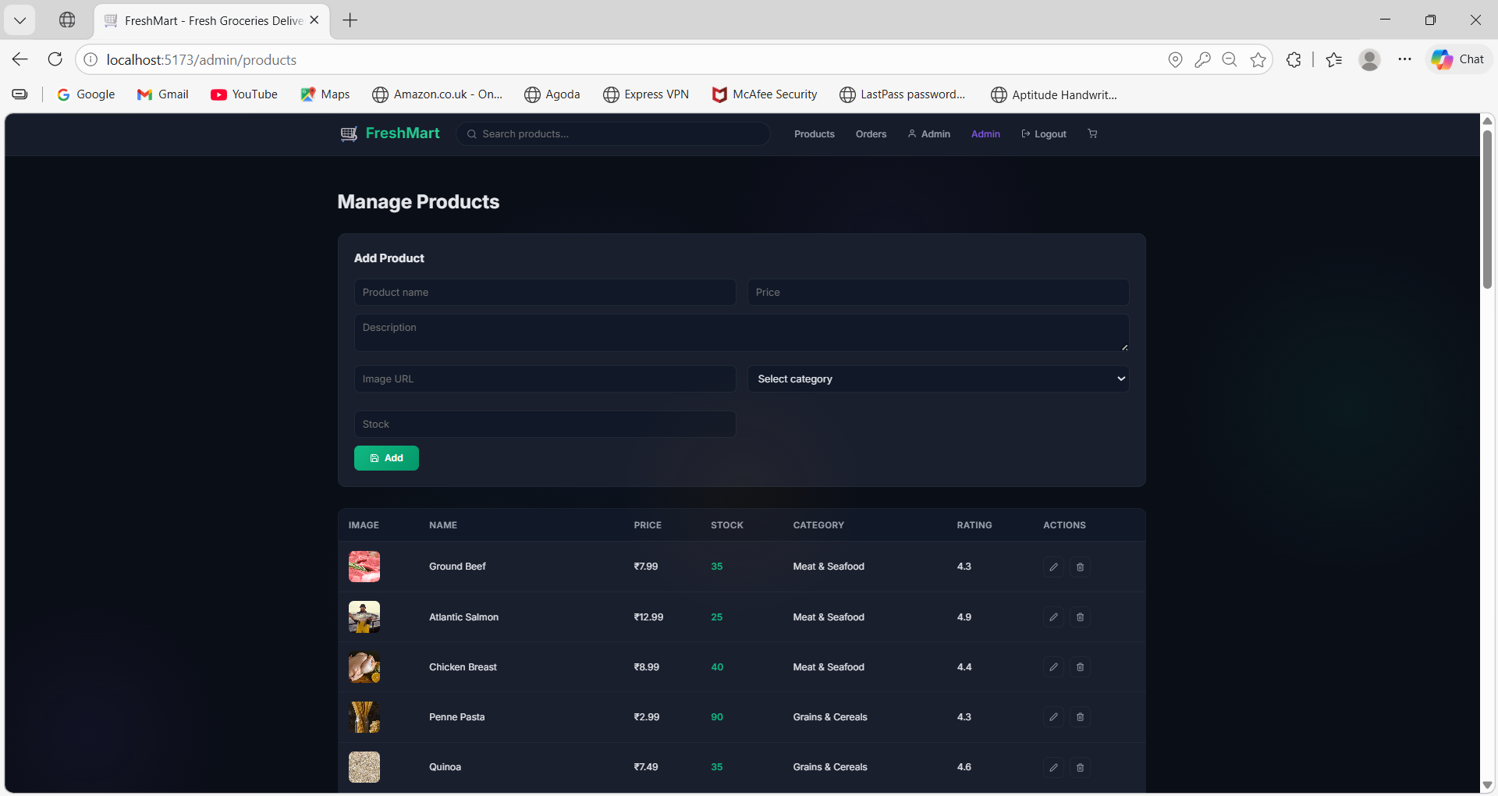

**Screen 11: Admin — Manage Orders**

Lists all customer orders with status, total, and user info. Admins can update order status from Pending to Confirmed, Shipped, or Delivered.

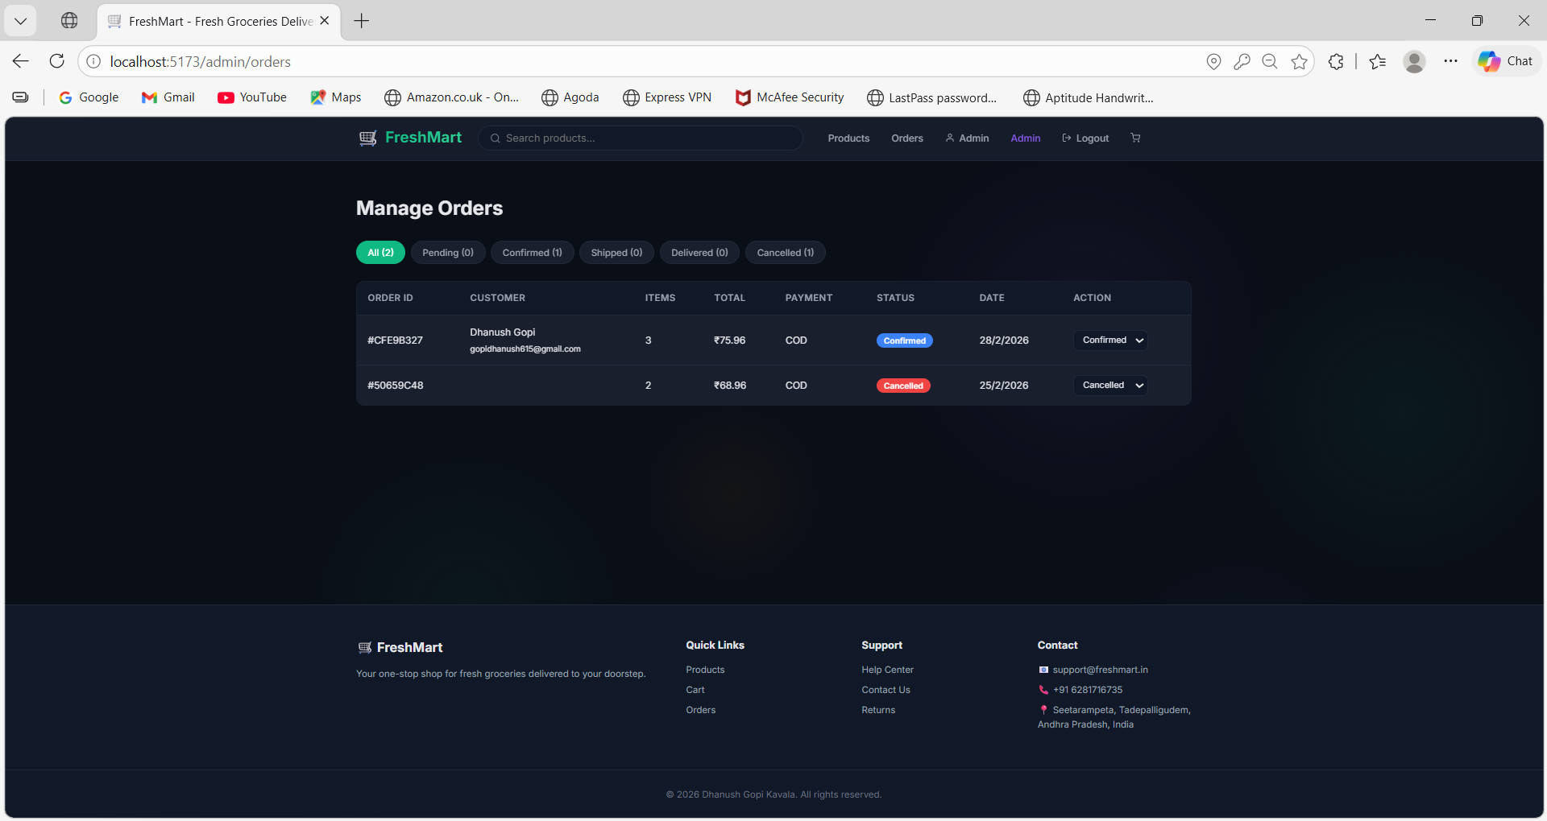

# 8. ADVANTAGES & DISADVANTAGES

**Advantages:**

* Full-Stack MERN Architecture: Single language (JavaScript) across the entire stack reduces context switching and simplifies development.
* Modern UI/UX: Dark-themed design with scroll-reveal animations, micro-interactions, and staggered card animations creates a premium feel.
* Secure Authentication: JWT-based stateless auth with bcryptjs password hashing follows industry security standards.
* Role-Based Access Control: Clear separation between customer and admin roles ensures secure feature access.
* RESTful API Design: Clean, well-structured API with consistent endpoints makes the backend maintainable and extensible.
* Real-Time Order Tracking: Status progression (Pending → Confirmed → Shipped → Delivered) keeps customers informed.
* Multiple Payment Options: Support for COD, Credit Card, Debit Card, and UPI covers diverse payment preferences.
* Responsive Design: Works seamlessly across desktop, tablet, and mobile devices.
* Database Seeder: Pre-built seeder script makes it easy to set up demo data for testing and presentations.
* Accessibility: Respects prefers-reduced-motion setting for users who prefer minimal animations.

**Disadvantages:**

* No Real Payment Gateway: Payment methods are simulated; no actual payment processing integration (Razorpay/Stripe).
* No Email Notifications: Users do not receive email confirmations for registration, orders, or status updates.
* Local Image URLs: Product images rely on external URLs; no image upload functionality is built in.
* No Inventory Auto-Update: Stock (countInStock) is not automatically decremented when orders are placed.
* Single Server Deployment: Both API and database run on the same machine in development; not horizontally scalable without additional configuration.
* No Search Auto-Suggest: The search function requires manual submission; no real-time autocomplete feature.
* No Wishlist Feature: Users cannot save products for later purchase.
* No Multi-Language Support: The application is English-only with no internationalization (i18n) support.

# 9. CONCLUSION

FreshMart is a comprehensive full-stack grocery web application that successfully demonstrates proficiency in modern web development technologies. The project covers the complete Software Development Life Cycle (SDLC) from ideation through deployment, implementing industry-standard practices at every stage.

The application delivers a production-grade grocery shopping platform with a visually stunning dark-themed UI, secure JWT authentication, role-based access control, and a feature-rich admin dashboard. Key accomplishments include:

* A fully functional e-commerce workflow: browse → search → cart → checkout → track → review.
* Secure user authentication with JWT tokens and bcryptjs password hashing.
* Admin dashboard with real-time analytics, product/category/order/user management.
* RESTful API with 20+ endpoints covering all CRUD operations.
* Modern UI with scroll-reveal animations, staggered card effects, and responsive design.
* Multiple payment method support (COD, Credit Card, Debit Card, UPI).
* Order tracking with visual status progression.

The project serves as a solid foundation for a real-world grocery delivery platform and demonstrates the ability to design, develop, test, and document a full-stack web application using the MERN stack.

# 10. FUTURE SCOPE

The following enhancements can be implemented in future versions of FreshMart:

* **Payment Gateway Integration:** Integrate Razorpay or Stripe for real-time payment processing with secure transaction handling.
* **Email & SMS Notifications:** Send order confirmations, status updates, and promotional emails using services like SendGrid or Twilio.
* **Image Upload System:** Allow admins to upload product images directly using Cloudinary or AWS S3 instead of external URLs.
* **Wishlist & Favorites:** Enable users to save products to a wishlist for future purchase consideration.
* **Real-Time Chat Support:** Implement live customer support chat using WebSocket (Socket.io) for instant assistance.
* **Progressive Web App (PWA):** Convert the frontend into a PWA for offline access, push notifications, and app-like experience.
* **AI-Powered Recommendations:** Use machine learning to provide personalized product recommendations based on purchase history.
* **Multi-Language Support (i18n):** Add internationalization support for Hindi, Telugu, and other regional languages.
* **Delivery Partner Integration:** Integrate with delivery services for real-time GPS tracking of orders.
* **Coupon & Discount System:** Implement promotional coupons, flash sales, and loyalty programs for customer retention.
* **Inventory Auto-Management:** Automatically update stock levels when orders are placed and alert admins on low stock.
* **Mobile App (React Native):** Build a cross-platform mobile application using React Native for iOS and Android.

# 11. APPENDIX

**Source Code**

The complete source code for FreshMart is organized into two main directories:

|  |  |  |
| --- | --- | --- |
| **Directory** | **Description** | **Key Files** |
| Backend/ | Express.js REST API server | server.js, seeder.js, controllers/*, models/*, routes/* |
| Frontend/ | React + Vite frontend application | App.jsx, api.js, pages/*, components/*, context/* |

**Installation Commands:**

# Clone the project  
cd "c:\Users\dhanush gopi\OneDrive\Desktop\FreshMart"  
  
# Install backend dependencies  
cd Backend  
npm install  
  
# Install frontend dependencies  
cd ..\Frontend  
npm install  
  
# Seed the database  
cd ..\Backend  
node seeder.js  
  
# Start backend (Terminal 1)  
cd Backend  
node server.js  
  
# Start frontend (Terminal 2)  
cd Frontend  
npx vite

**Dataset Link**

The application uses a built-in database seeder (seeder.js) that populates the MongoDB database with sample data including:

* 2 users (1 admin + 1 regular user)
* 8 product categories (Fruits, Vegetables, Dairy, Bakery, Beverages, Snacks, Meat & Seafood, Frozen Foods)
* 20 grocery products with images, prices, descriptions, and stock counts

**Demo Credentials:**

|  |  |  |
| --- | --- | --- |
| **Role** | **Email** | **Password** |
| Admin | admin@grocery.com | admin123 |
| User | john@example.com | password123 |

**GitHub & Project Demo**

|  |  |
| --- | --- |
| **Resource** | **Link** |
| GitHub Repository | https://github.com/dhanushgopi2456/FreshMart |
| Local Frontend URL | http://localhost:5173 |
| Local Backend API URL | http://localhost:5000/api |

**Environment Configuration (Backend/.env):**

|  |  |  |
| --- | --- | --- |
| **Variable** | **Default Value** | **Description** |
| PORT | 5000 | Backend server port |
| MONGO_URI | mongodb://localhost:27017/groceryapp | MongoDB connection string |
| JWT_SECRET | grocery_app_super_secret_key_2024 | JWT signing secret |
| NODE_ENV | development | Environment mode |

**— End of Project Report —**